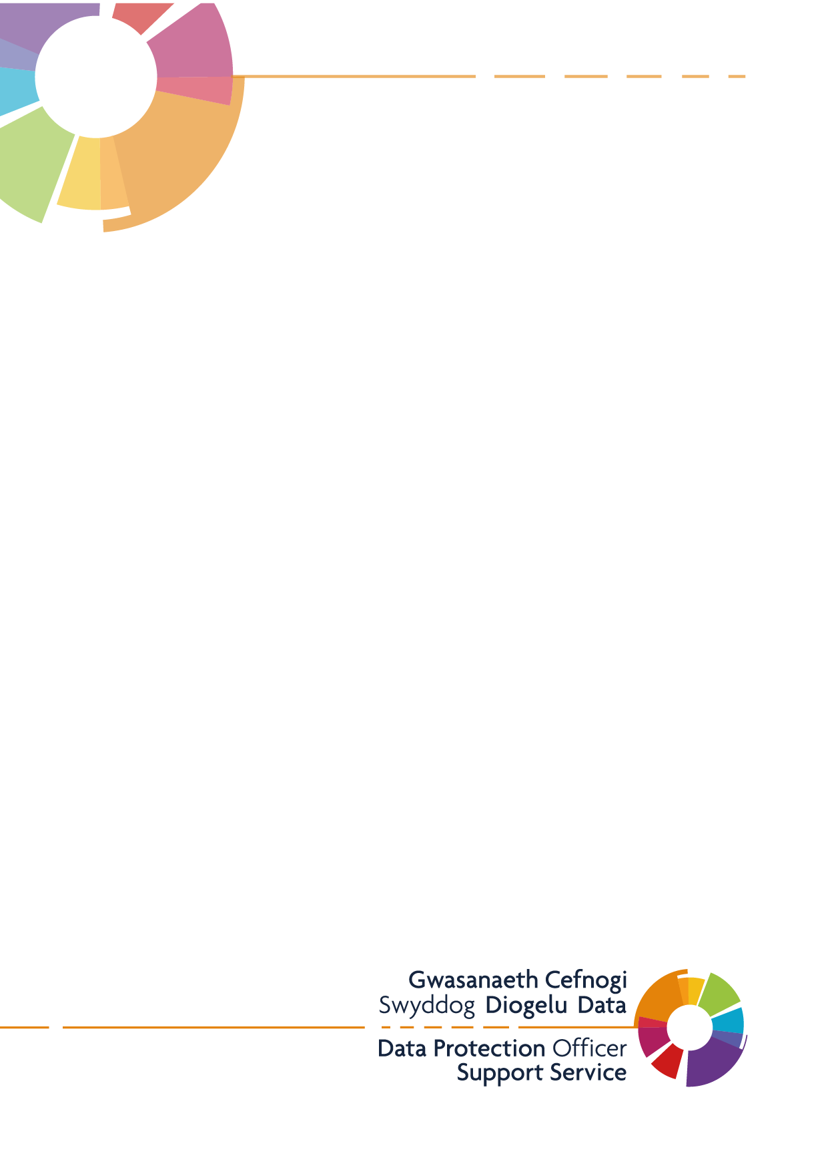
Publication Scheme
Cwmfelin Medical Centre

Introduction
This example publication scheme has been created to outline the types of information that the Practice is expected to publish. The example is based upon the ICO model publication scheme and is broken down into the classes of information required under the Freedom of Information Act 2000. It is recommended that this is laid out in its own section of your Practice’s website, with the below headings listed.
Your Rights to Information
The Freedom of Information Act (FOI) 2000 provides members of the public with the right access information held by public authorities.
Public authorities are required to routinely publish certain information to the public as part of its normal business activities. This is known as a publication scheme.
The Cwmfelin Medical Centre Publication Scheme is designed to signpost individuals to information we proactively release as and when it becomes available. The aim of this is to explain what information the practice makes available to the public and where possible to provide an easy method of accessing it.
The Publication Scheme contains seven classes of information, as follows, and information falling into each of these classes is published on our practice website:
- Who we are and what we do
- What we spend and how we spend it
- What are our priorities and how we are doing
- How we make decisions
- Our policies and procedures
- Register of members’ interests
- Services we offer
All the information we proactively release is available free of charge on our website. Our publication scheme is a useful place to start if you’re looking for information about Cwmfelin Medical Centre, before making a Freedom of Information request.
Information that is not published under the FOI Publication Scheme can be requested in writing and the release of such information will be considered in accordance with the provisions of the FOI Act 2000.
To make a Freedom of Information request, please email contact the practice reception.emailw98003@wales.nhs.uk or write to:
Practice Manager
Cwmfelin Medical Centre
298 Carmarthen Road
Swansea
SA1 1HW
Who we are and what we do
This section of your scheme would include information regarding:
- Organisational information
- locations and contacts

This may include information relating to the structure of the practice, members of staff, locations and opening times.
EXAMPLE:
- Cwmfelin Medical has 8300 patients in the Penderi Area. We are also a member of the Penderi Cluster which is made up of 5 separate Practices. The cluster Practices can be found on this website: Penderi Cluster -
- The practice was formed in 1994.
- Practice details and our opening times are published on our website, this information be accessed via the [insert website link] page
- The following people work in the Practice (Here you can link to your webpage if you have the information readily available there):
Partners:
Salaried GPs:
Nurses:
The Practice Team:
Admin Staff:
Other information is available on the practice notice boards and display tables in the waiting areas.

What we spend and how we spend it
This section is to be filled with information regarding your annual accounts, salaries, and any expenses your Practice has accumulated. This should include information relating to financial projected information and actual income and expenditure, tendering, procurement and contracts. This area may also include any agreements and contracts that your Practice has in place with third parties (a common one here will most likely be a data shredding company).
Some areas to consider is:
- Expenditure over £10k
- Financial performance reports
- Financial audit reports
- Annual accounts
- Capital Programme
- Standing Financial Instructions
- Declaration of GPs’ NHS income
EXAMPLE:
- [Practice name] receives money from NHS Wales according to its contract for national General Medical Services in exchange for services provided for patients.
- The total income received from the NHS before expenses was £X for the year ending XX/XX/XXXX.
- There may be circumstances where material cannot be released because it is confidential or commercial information or the appropriate officer designated for these purposes, under the Act, has taken the view that it may be prejudicial to the conduct of the Practice’s affairs.
If this is the case, we will respond to your FOI request with a formal letter acknowledging the reasons why we are unable to give you this information.
- We do not wish to publish our annual salaries, but they are available on request.

What our priorities are and how we are doing
This can be used to outline anything that your practice feels is a top priority for you. This may outline strategy and performance information, plans, assessments, inspections and reviews.
This also allows the practice to publish any new plans or schemes, for example, are you creating a new system for following up on elderly patients who have been discharged from hospital?
EXAMPLE:
1) Currently our top priority is helping our patients and staff through the Covid-19 crisis. We have implemented video consultations in order to minimise the number of patients in our waiting room. We do however run an emergency clinic every Monday, Wednesday, and Friday. We ask that patients stay in their car and call the Practice when they arrive. A member of staff will then come out and collect you.
2) For further updates and policies regarding the Covid-19 crisis and the Practice please see our website (website link)
3) We are currently working closely with our colleagues in the [Name] Cluster to develop and improve services for patients in the local area. Our cluster plan can be found here (website link)
4) We were last inspected by Care Inspectorate Wales [insert date] a copy of the inspection report is available here [insert link].

How we make decisions
Does your practice have a committee or board who are responsible for making decisions? If so information regarding them can be put under this heading – including the minutes of those meetings (redacted if they include personal / third party information). This could also include future Policy proposals and decisions, the decision-making processes, internal criteria, procedures and any consultations.
EXAMPLE
1) [Practice name] has a committee that is made up of the senior partners and management. Please find more information about the committee on our website. (website address).
2)The Committee meets every 1st Thursday of the month. Below are links to the previous year’s minutes – anything older or newer will be on our website. (Links to committee minutes)

Our Policies and Procedures
This section provides information about current written protocols for delivering the practice’s functions and responsibilities. All practice policies and procedures need to be made easily available to Practice staff and members of the public, it is recommended that they are published on your website. As a minimum you should list all policies and procedures and detail how these can be accessed. Additionally, information about your Practices complaints procedure should be included.
EXAMPLE
1) Our Policies and Procedures
General policies and procedures in use within the practice include, but are not limited to:
- Data Protection
- Prescribing
- Zero Tolerance
2) All policies and procedures are available for viewing, upon request in writing, please contact the Practice Manager (email contact or email link)
3) If you have a complaint or concerns about the service you have received from the doctors or any of the staff working in this practice, please let us know. We operate a complaints procedure as part of the NHS system. Our complaints system meets national criteria.
4) A copy of our practice complaints procedure is available here (website link) This will give you all the information and contact details needed to lodge a complaint.

Lists and Registers
This section would include any lists or registers the practice is required to keep for example declarations of interest register or hospitality and gifts registers and registers relating to the functions of the authority. Details of the locations of any overt CCTV cameras should also be included.
EXAMPLE
  - Nurse Practitioner – [Name] is also on the Nursing disciplinary panel at Cardiff and Vale Health Board
  - The Practice operates two CCTV cameras covering the car park and entrance to the Practice.
The services we offer
This should include advice and guidance, booklets and leaflets, transactions and media releases. A list of the services your practice can offer their Patients.
EXAMPLE
  - In addition to routine and emergency services, we offer the following range of services under contract to the NHS:
Maternity Medical Services
- Contraceptive Services
- Minor Surgery

  - Charges for our private services (including medical reports and travel vaccinations) are published on our website, this information be accessed via the [insert website link] page

Additional - Disclosure Log

A disclosure log is used to publish any previous FOI requests and the response to these. For example, if someone asked you how often your practice gets a deep clean, the information you give to them can be published in this area. This will be helpful when people are looking to submit an FOI request to your practice, as then can check this log beforehand to see if the information they require has already been requested and published.

The method by which information published under this scheme will be made available
The practice will indicate clearly to the public what information is covered by this scheme and how it can be obtained.
Where it is within the capability of the practice, information will be provided on the website. Where it is impracticable to make information available on a website or when an individual does not wish to access the information by the website, the practice will assist to provide the information in the format it has been requested or offer an alternative method for it to be obtained.

Charges which may be made for information published under this scheme
The purpose of this scheme is to make the maximum amount of information readily available at minimum inconvenience and cost to the public. Charges made by the practice for routinely published material will be justified and transparent and kept to a minimum. Material which is published and accessed on a website will be provided free of charge.
Generally, only the following charges can be made:
- the costs directly incurred as a result of viewing information, photocopying, postage and packaging
- fees permitted by other legislation; and
- for information produced commercially, for example, a book, map or similar publication that you intend to sell and would not otherwise have produced.

